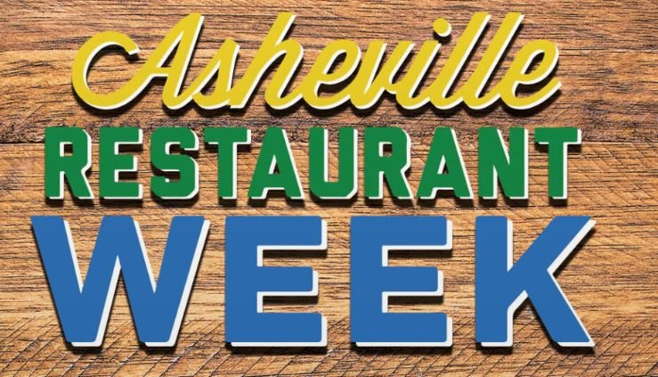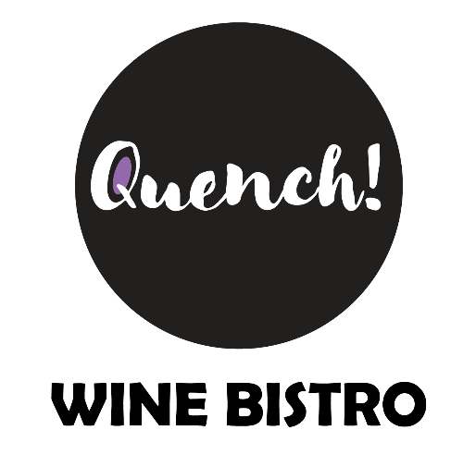

Restaurant Week Menu is $35 a person/optional wine pairing $20 a person-

First Course (Choice of one)-

-Arugula salad, Italian speck ham, shaved parmesan Reggiano, marinated olives, cherry tomatoes, lemon honey vinaigrette (paired with Campodora)

-NC Oyster Chowder, fingerling potatoes, oyster crackers, sherry(paired with Domaine St. Landor Saumur Blanc)

- Tomato Bisque, garden pesto, grilled cheese croutons(paired with Bric Amel Arneis blend)

Second Course(Choice of one)-

-Blue Cheese Mussels, fresh linguine, local mushrooms, crostini (paired with Poderi Nespoli Sangiovese)

-Shrimp and grits or veggies and grits, creole sauce, Farm and Sparrow cheese grits (paired with Ceretto Dolcetto D’Alba)

- Beef Bourguignon-red wine braised short ribs, pearl onions, Black Trumpet Farm’s mushrooms (paired with Arbalest Bordeaux)

Dessert Course(Choice of One)-

-Chocolate and Luxardo Cherry Pot de Crème, pistachio (paired with Domaine La Fage Grenache)

-Bourbon butterscotch pudding, sea salt caramel(paired with RWC Charleston Special Madeira)